Password Cracking
OS CREDENTIAL DUMPING: LSASS MEMORY

* On windows :
download procdump :
download netcat :
https://eternallybored.org/misc/netcat/netcat-win32-1.11.zip
Sur powershell en tant qu’admin
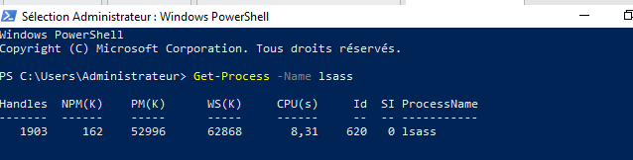
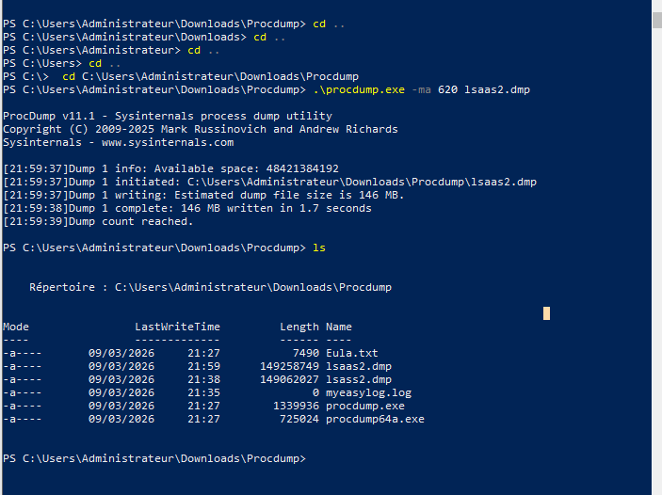
Sur kali
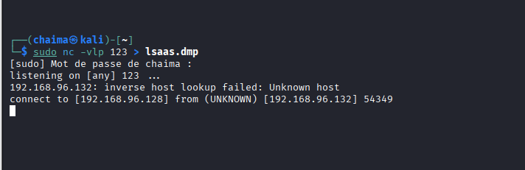
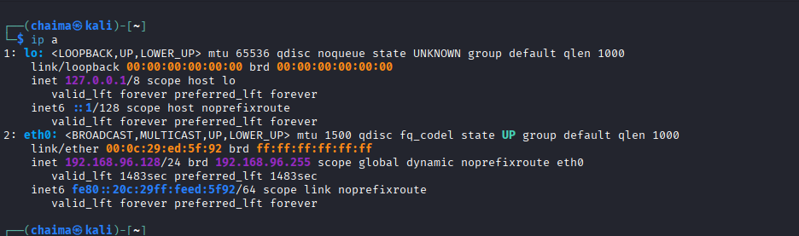
Sur Invite des commandes
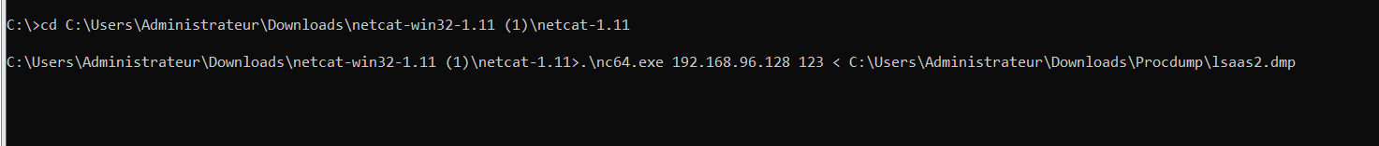
Sur kali
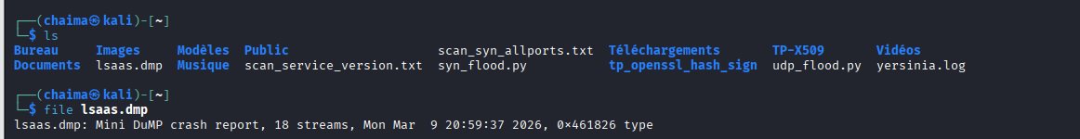
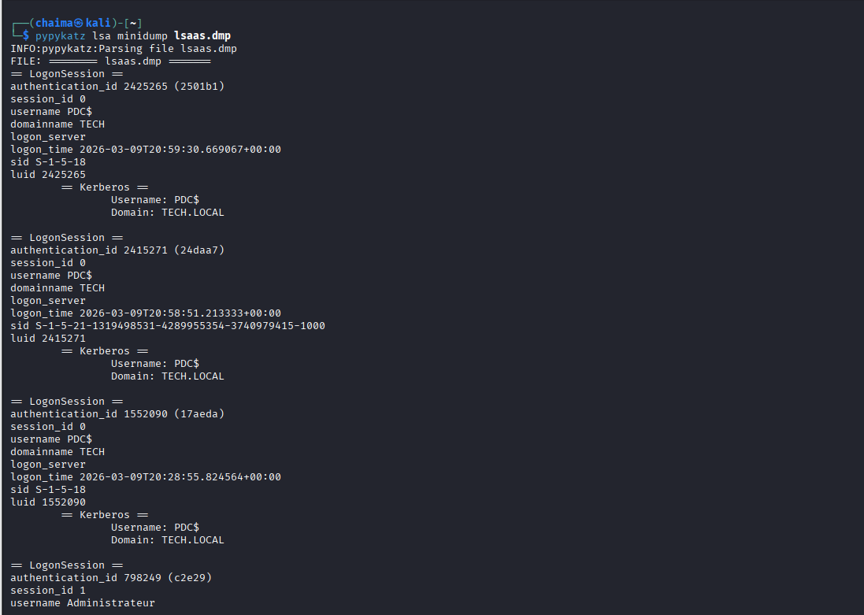
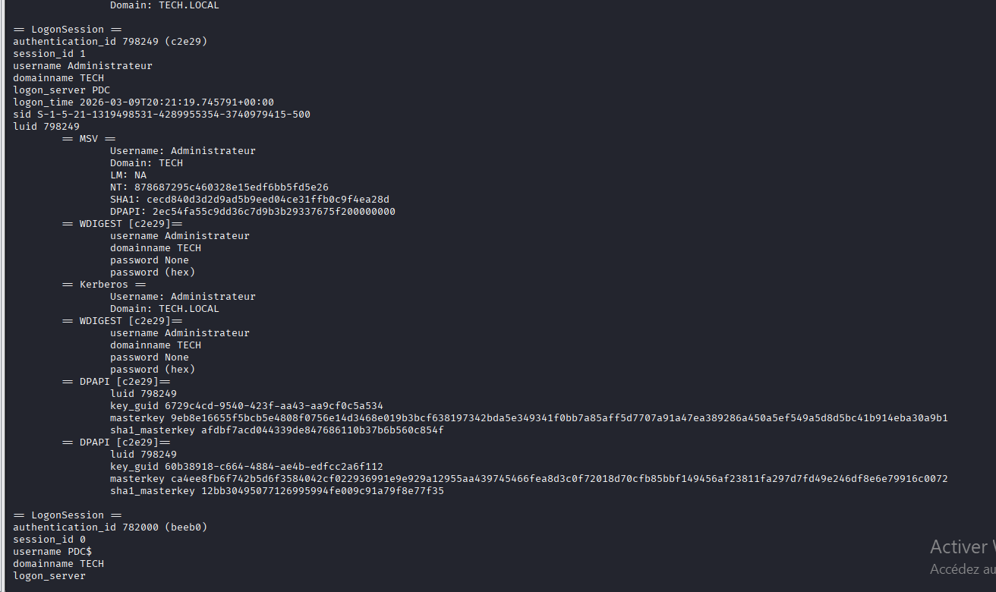
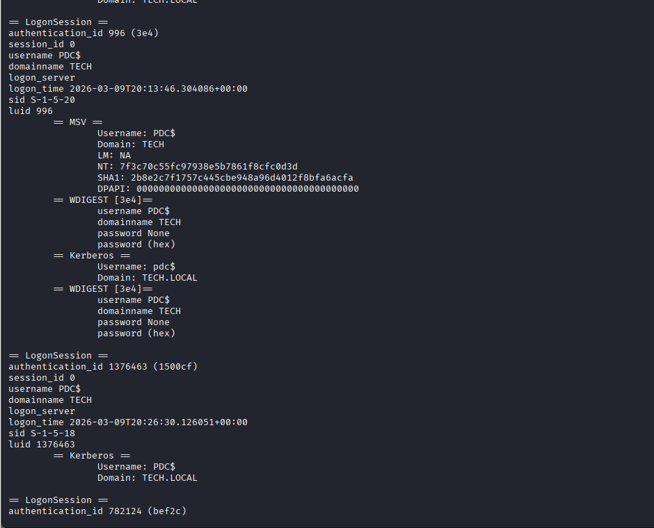
Keylogger making with msfvenom
Objectif: create a kelogger with msfvenom to log password entered by victim and send it to attacker
